How to Use TodaysMeet.Com

Teacher:
- Go to todaysmeet.com
- Name your “room”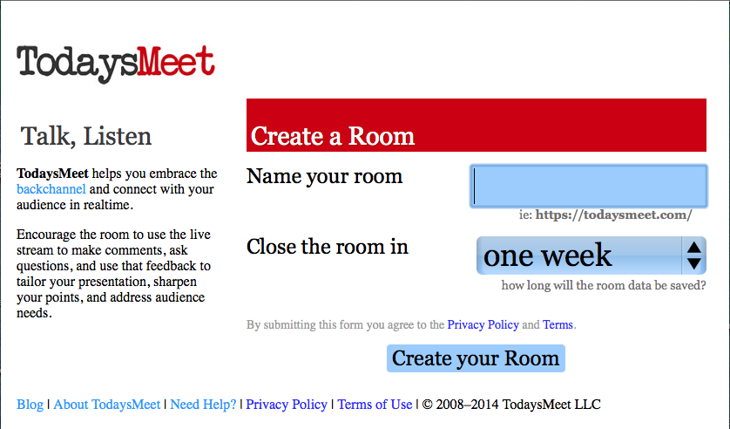
  - If the name is available, a green check will appear. If not available, a red X will show and you’ll have to use a different name
  - Room names can be reused, but not until the current room by that name closes.
  - I use my school’s initials (sshs) and my room number (303) as my “room name”.
  - If I need small groups, I add a period number or group number (eg: sshs303group2)

- Select the time your room will be open (you cannot use the same name for a new class or conversation until it closes)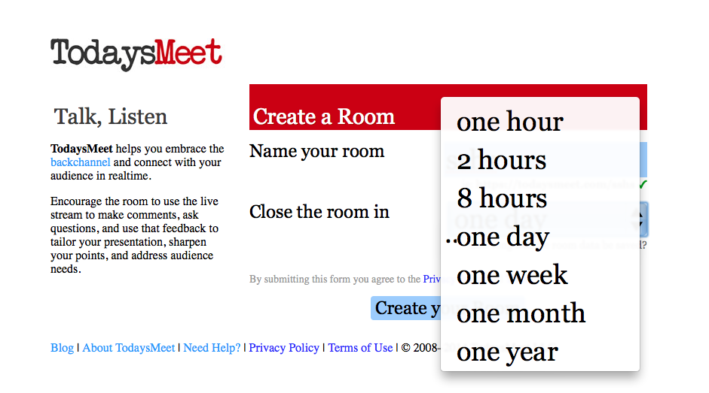
  - If you want to reuse your room name frequently, select “one day” or “eight hours” as your time.
  - Select “one week”, or longer, for projects and ongoing discussions.

- Sign in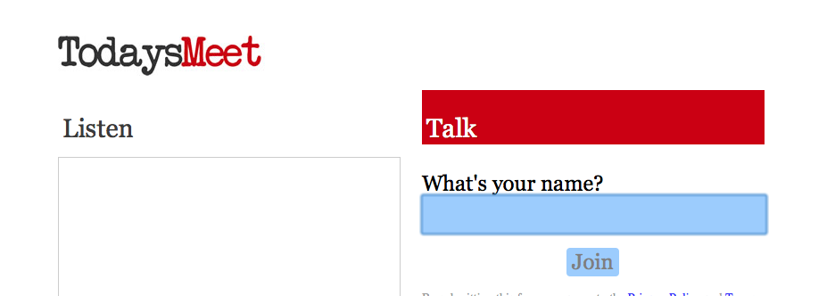
- post your instructions (guided question, task, etc)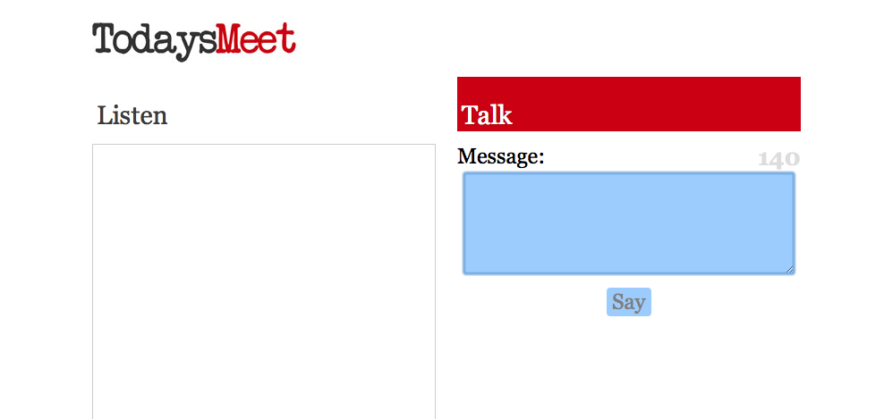
  - Option: “projector” view if displaying conversation on screen at front of room
  - Option: click on gear symbol and turn on “show speaker colors” to easily see who is posting.

- Recommended: save, or print, a transcript of the discussion (transcripts are shown/saved in chronological order)

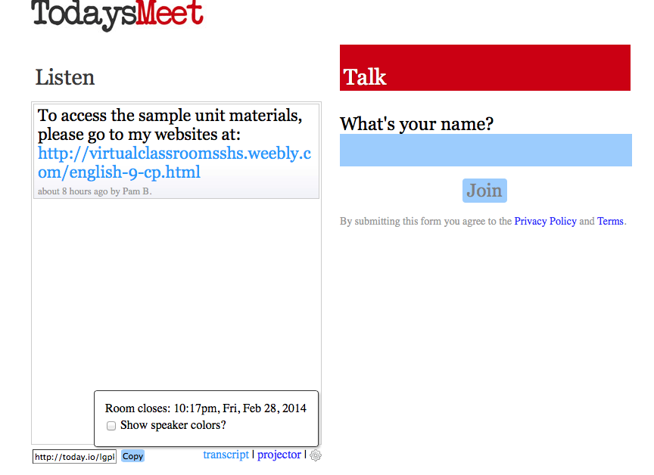

Students:
- Go to todaysmeet.com/room name
- Log in with your first name and last initial (to receive credit for posting)
- Use standard English and complete sentences. No “text speak” or hashtags.
- Stay on topic.
- Post appropriately. School rules and AUP are in effect.

